Please invite your JP2 friends (or anyone else that might be interested) to like our Facebook page. The easiest way to do this is:

1. From your computer:
- Go to Shanley Athletic Club SAC Facebook page
- Like it if you haven’t already
- On the right side of the page click “Invite friends to like this page”
- Invite your friends and family!
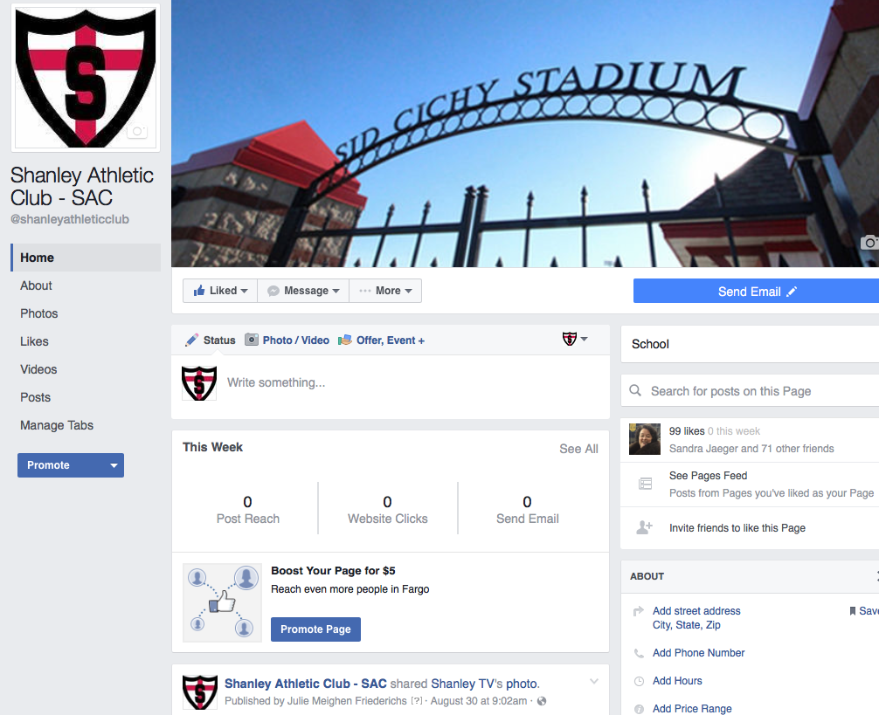
Click right here!
⬅ 
2. From your phone:
- Go to Shanley Athletic Club SAC Facebook page
- Like it if you haven’t already
- Click “Invite friends to like this page”
- Invite your friends and family
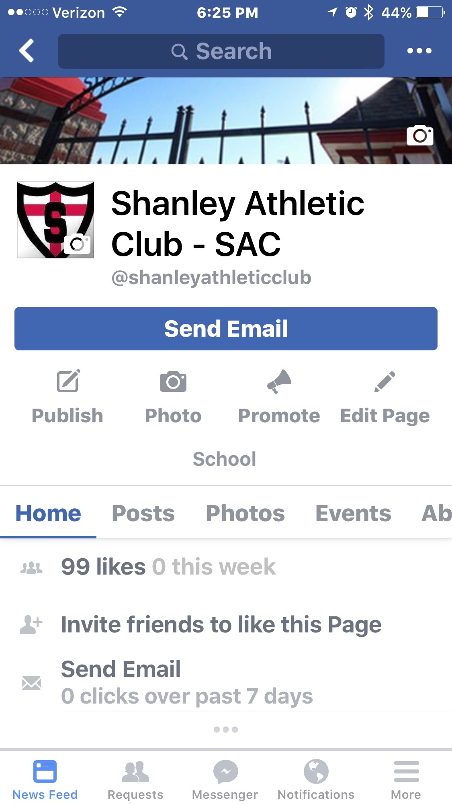
Click right here!

⬅ 

